Getting Started with Jenkins

* First job: Execute a bash script
* **It will be executed inside the container and not the host**
* Get inside the container. First get the container name with docker ps
  + *docker ps*
  + *docker exec -ti CONTAINER_NAME bash*

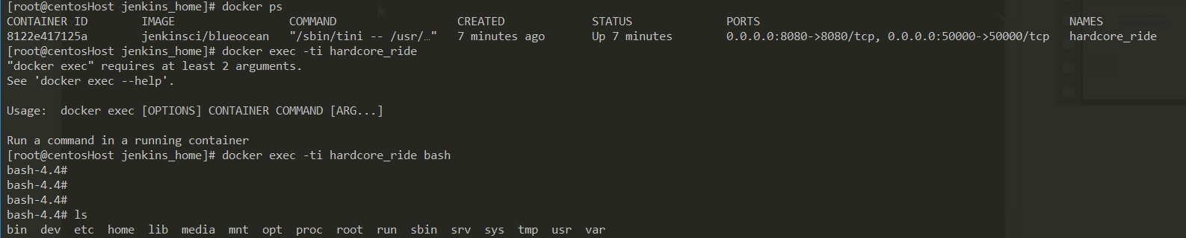

* Jenkins job with parameters.